Product: | 40-985/901G | 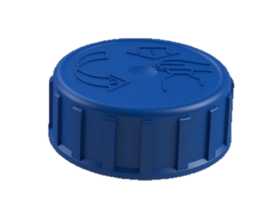
Article number: | Please contact our sales department.
Product Description: | 40mm child resistant closure with liner adapted for P40-thread.
Technical specifications
Drawings: | Product drawing: S 40-985BS_00-901G  Neck drawing: H 985BS
Sealing: | Liner: EPE/PET
Plastic resin: | Cover: HDPE  Closure: HDPE
Master batch: | Please contact our sales department.
Recommended capping torque: | 2,5-3,0Nm
Storage durability: | 1 year, keep room temperatured in tightly sealed cardboard boxes.
Certificate | ZERT 06951530614-8317  The package can only be designated as child resistant and suitable for adults if certified package are used according to ISO 8317.
Quality Control
Standards and norms | Sampling procedure: SS 020130-ISO2859 normal 1  Defect classes according to KP-002
Delivery
Packaging | 1.600 pcs packed in plastic bag, packed in cardboard boxes 82dm³. Labels on the boxes. 16 boxes on each pallet with stretch film wrapped around.
Traceability | Marking for traceability contains EVP article number, customer article number, production order number, pieces per carton, EVP order number customer order number and date and signature.

