Product: |  | 28-321 | 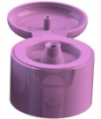  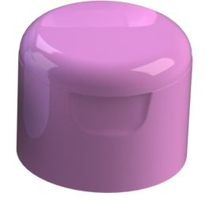
Article number: |  | Please contact our sales department.
Product Description: |  | 28mm Flip-top closure with groove deck adapted for P28-thread.
Technical specifications
Drawings: |  | Product drawing: S 28-321  Neck drawing: H 321
Sealing: |  | Ring seal
Plastic resin: |  | PPH
Master batch: |  | Please contact our sales department.
Recommended  capping torque: |  | 1,7-2,0 Nm
Storage durability: |  | 1 year, keep room temperatured in tightly sealed cardboard boxes.
Quality Control
Standards and norms |  | Sampling procedure: SS 020130-ISO2859 normal 1  Defect classes according to KP-002
Delivery
Packaging | 2 800 pcs packed in plastic bag packed in cardboard boxes 82dm³. Labels on the boxes. 16 boxes on each pallet with stretch film wrapped around.
Traceability | Marking for traceability contains EVP article number, customer article number, production order number, pieces per carton, EVP order number customer order number and date and signature.

