Product: |  | 00-228 | 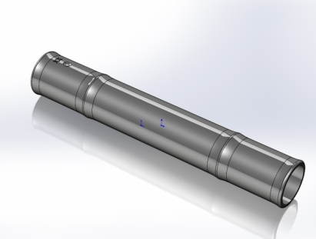
Article number: |  | Please contact our sales department.
Product Description: |  | Handle
Technical specifications
Drawings: |  | Product drawing: S00-228
Sealing: |  | -
Plastic resin: |  | HDPE
Master batch: |  | Please contact our sales department.
Recommended capping torque: |  | -
Storage durability: |  | 1 year, keep room temperatured in tightly sealed cardboard boxes.
Quality Control
Standards and norms |  | Sampling procedure: SS 020130-ISO2859 normal 1  Defect classes according to KP-002
Delivery
Packaging | 24 000 pcs packed in plastic bag, packed in plastic container 1200x800x970mm. The plactic containers shall be returned to EVP.
Traceability | Marking for traceability contains EVP article number, customer article number, production order number, pieces per carton, EVP order number customer order number and date and signature.

