Product: |  | 210/211 Dropless tamper-evident closure | 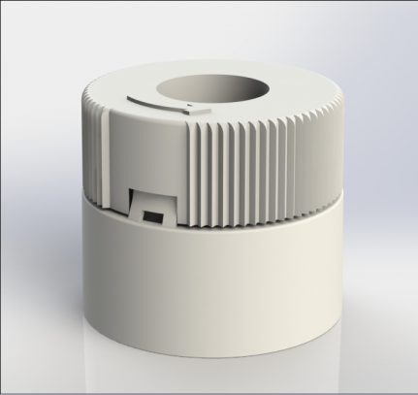
Article number: |  | 49003545, 49003548, 49003863, 49003556, 49003551
Product Description: |  | Dropless snap-on closure for glass-, & PET bottles. Closure consists of neckpart and upper part assembled together. Closure is used for liquid pharmaceuticals.
Technical specifications
Drawings: |  | Product drawing: EVP 12411  Neck drawing: X-616, H210, H210 PET
Symbols |  | Upper part is ribbed. Arrow on upper part shows opening direction.
Plastic resin: |  | Neck part: polypropylene impact polymer Purell EP274P, DMF-reg  Upper part: polypropylene homopolymer Borealis HF840MO, DMF-reg
Master batch: |  | 49003545:  White 201/201 Clariant Masterbatches PP12455, DMF-reg  49003548:  Silver 333/333 Holland Colors 115767  49003863:  Yellow 761/761 Kunststof 21-2140-PY 191  49003556:  Green 8118/8118 Kunststof 26-22276  49003551:  Blue 9164 Kunststof 15-22738  White 201 Clariant Masterbatches PP12455, DMF-reg
Injection moulding: |  | Neckpart and upper part is injection moulded in clean room ISO 14644-1 class 8
Assembly |  | Injection moulded parts are assembled in clean room ISO 14644-1 class 8
Capping |  | The closure should be snaped on axially to the bottle at min 18°C. Needed assembly force could vary. For glass bottles a slight preheating of the cap decrease the needed assembly force.
Storage durability: |  | 1 year, keep room temperatured in tightly sealed carbon boxes.
Quality Control
Standards and norms |  | Sampling procedure: SS 020130-ISO2859 normal 1  Defect classes according to KP-002
Internal inspection |  | Setup and operator’s inspection, assembly inspection and final inspection.
Leakage test |  | According to LIF method 19:6
Cert. of conformance |  | KBSK-210/-212
Delivery
Packaging | 1200 pcs packed in double plastic bags closed with strap, labelled on inner bag, packed in cardboard boxes 45dm³ cardboard boxes. 30 boxes on pallet with stretch film wrapped around..
Traceability | Marking for traceability contains EVP article number, customer article number, production order number, pieces per carton, EVP order number customer order number and date and signature.

